

**PROJECT NAME: PERSONAL BLOG USING IBM CLOUD STATIC WEB APPS**

**PHASE 5 : PROJECT DOCUMENTATION & SUBMISSION**

## PROJECT MEMBERS :

NAME REGISTER NO

ANNE AKSHAYA R 210621205003

GOWSIKA R 210621205017

SOWNDHARYA K 210621205049

SRUTHIKA N 210621205050

VIJAYALAKSHMI J 210621205055

**INDEX**

|  |  |  |
| --- | --- | --- |
| S.no | Topic | Page no |
| 1 | Project OBJECTIVE | 3 |
| 2 | DESIGN THINKING PROCESS | 3 |
| 3 | DEVELOPMENT PHASES | 4 |
| 4 | PLATFORM LAYOUT | 12 |
| 5 | FEATURES | 13 |
| 6 | TECHNICAL IMPLEMENTATION | 14 |
| 7 | Outputs | 15 |
| 8 | CONCLUSION | 22 |

PERSONAL BLOG USING IBM CLOUD STATIC WEB APPS

##### Project Objective:

Our goal is creating a personal travel blog hosted on IBM Cloud Static Web Apps to share travel adventures, tips, and captivating photos.

**DESIGN THINKING PROCESS:**

**Define Design Goals and User Experience:**

•Identifying the target audience for the travel blog.

•Understanding the purpose of the blog and what kind of content will be featured.

•Defining the desired user experience, such as a sense of adventure, navigation ease, and multimedia content engagement.

**Multimedia Integration:**

•Planning how to showcase multimedia content, such as photos, videos, and interactive maps.

•Ensuring that multimedia elements are visually appealing and enhance the storytelling aspect of the blog.

**Interactive Features:**

•Incorporating interactive elements like social media buttons, image galleries, and maps to engage users.

•Implementing comment sections for user interaction and feedback.

**Responsive Design:**

•Ensuring that the design is responsive and adapts to various screen sizes, including desktop, tablet, and mobile devices.

•Testing the responsiveness of the design on different devices to ensure a consistent user experience.

**Final Design Mock-ups:**

•Developing final design mock-ups for all key pages of the blog.

•Ensuring that the design is consistent across the entire website.

## development phases:

**PHASE 1**

In Phase 1, we established the problem statement and outlined the design thinking concept for our personal travel blog project. We identified the need for an easily updatable blog hosted on IBM Cloud Static Web Apps to document travel experiences and inspire others to explore the beauty of the world.

**PHASE 2**

In Phase 2 we included ideas to enhance user engagement and interaction by integrating key features such as social media contact buttons and comment sections.

**PHASE 3**

In Phase 3 we started designing and developing the static travel blog website using HTML, CSS & JS, creating engaging content with captivating photos and travel stories also in this phase we are providing our data sets, coding of our travel blog website & also our output of our initial development.

**PHASE 4**

To create a bucket in IBM Cloud Object Storage, follow these steps:

Step 1 : Login to IBM Cloud.

dashboard will be open.

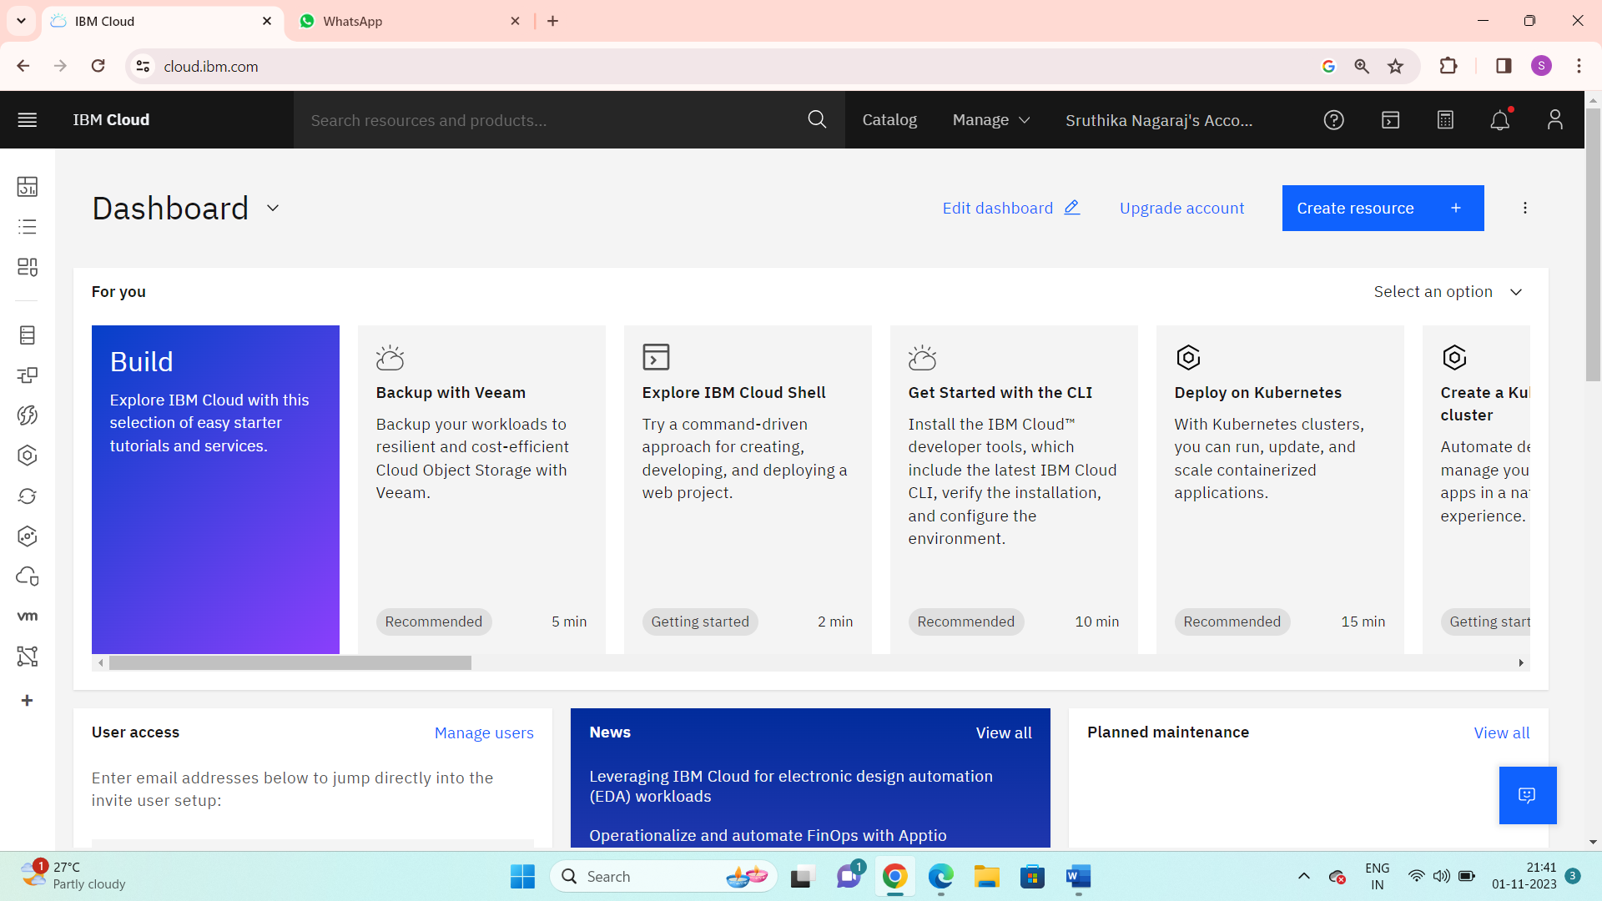

Step 2: Go to catalog. And search IBM Cognos dashboard embedded

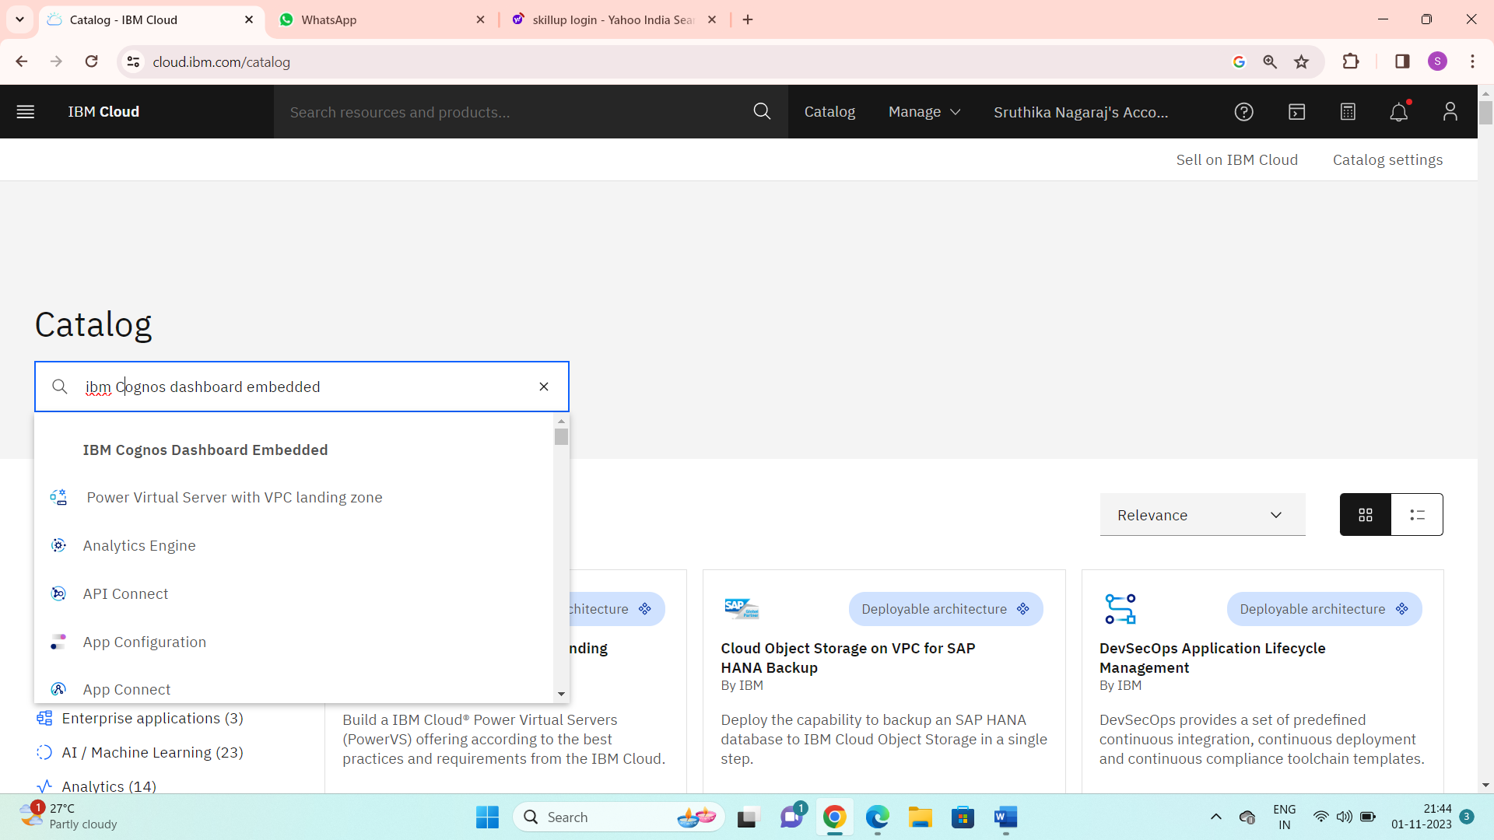

Step3: Choose location and plan as per below. Click create.

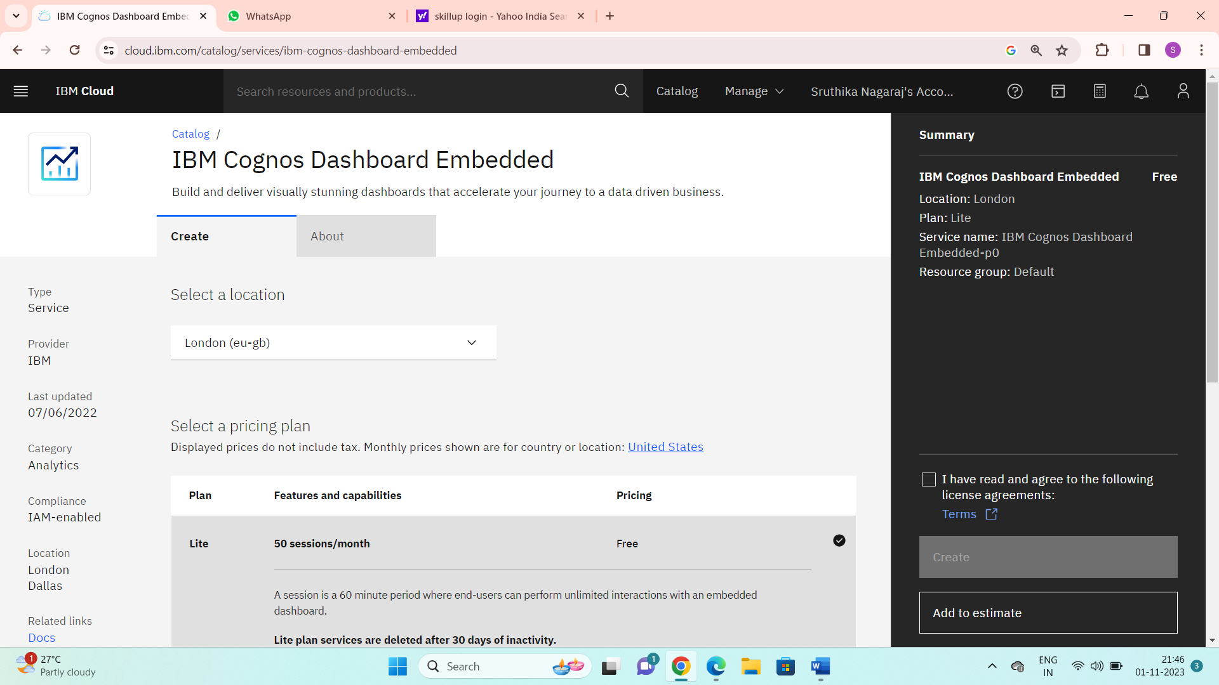

Step 4: Go to resource list and search cloud object storage.

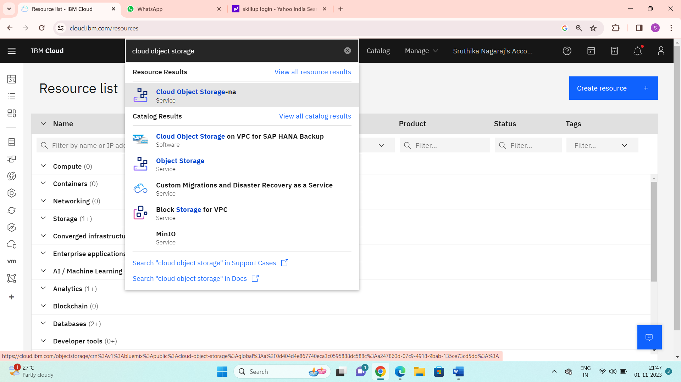

Step 5: Then the cloud object storage will be displayed. Click on create bucket. Then the below page is displayed. Click create.

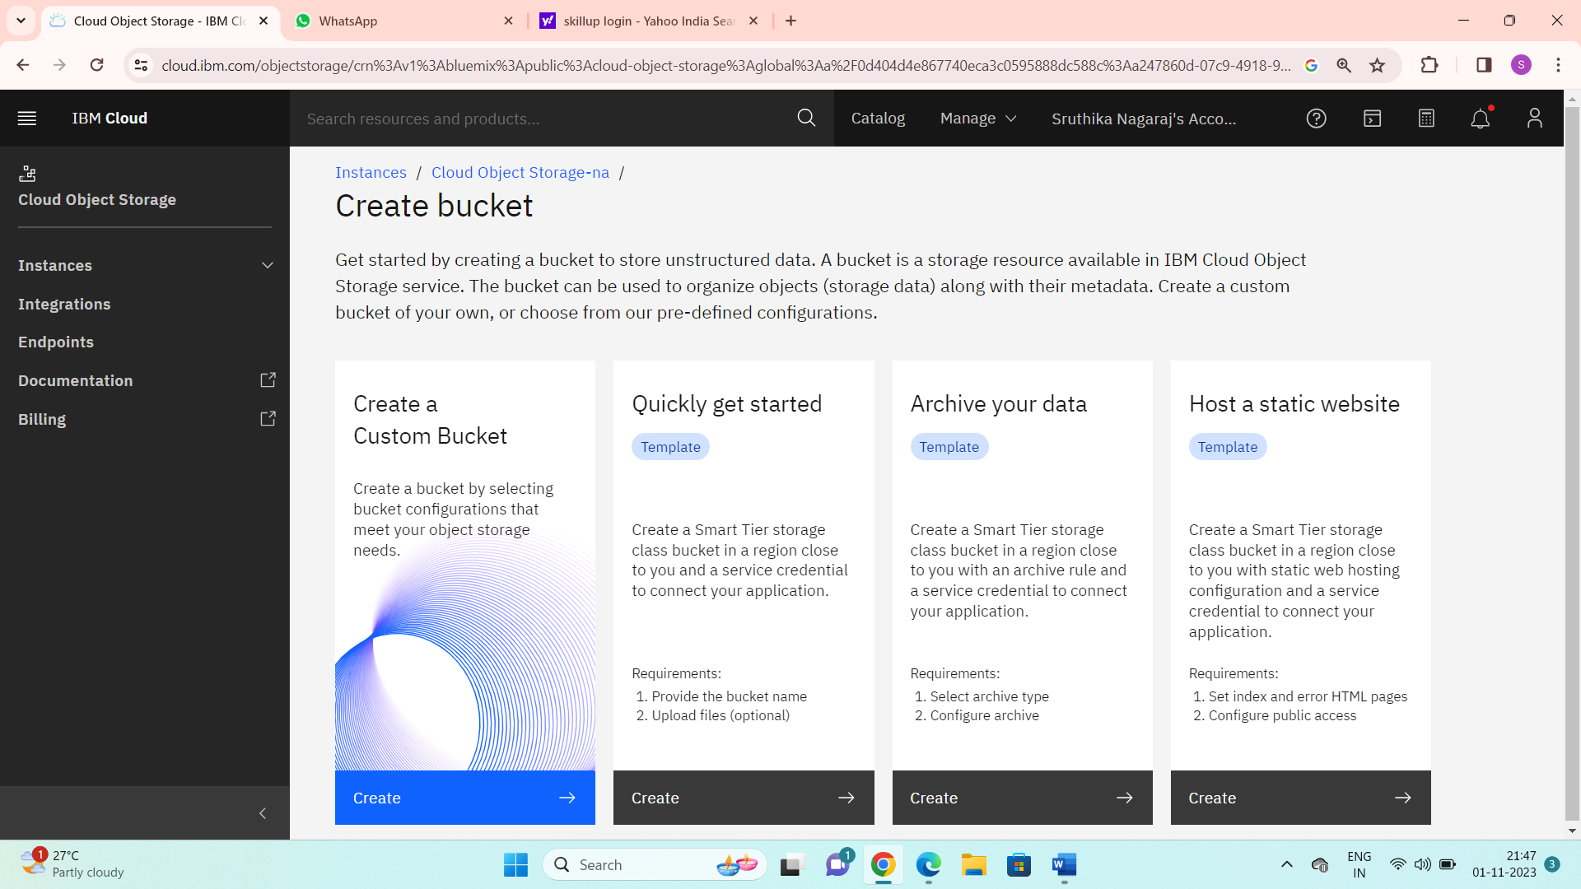

Step 6: Then give the unique name for bucket as my.travel.blog.

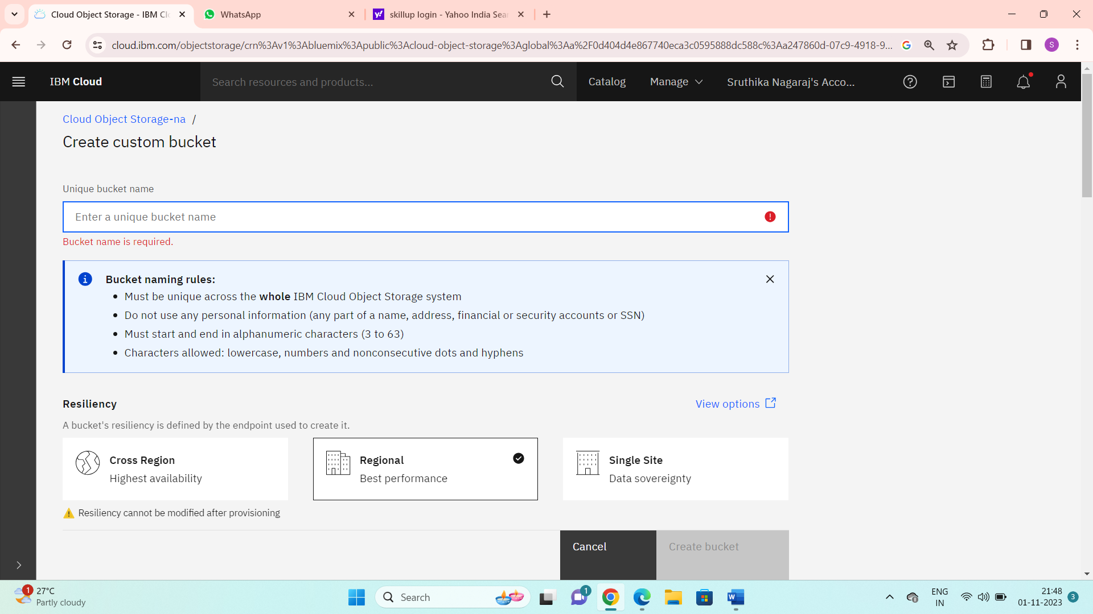

Step 7: Now, go to static website hosting and enable public access and save it.

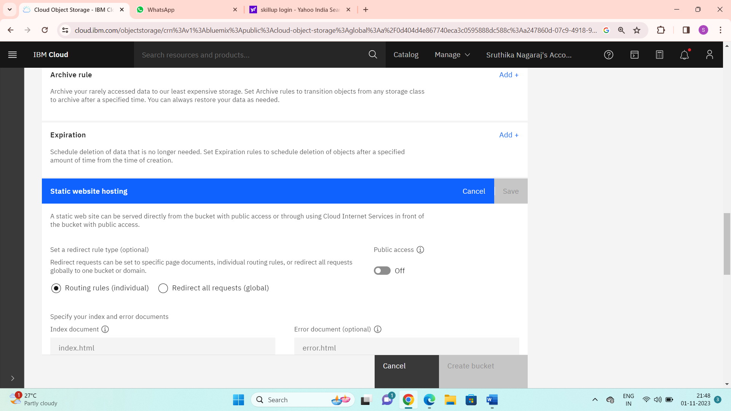

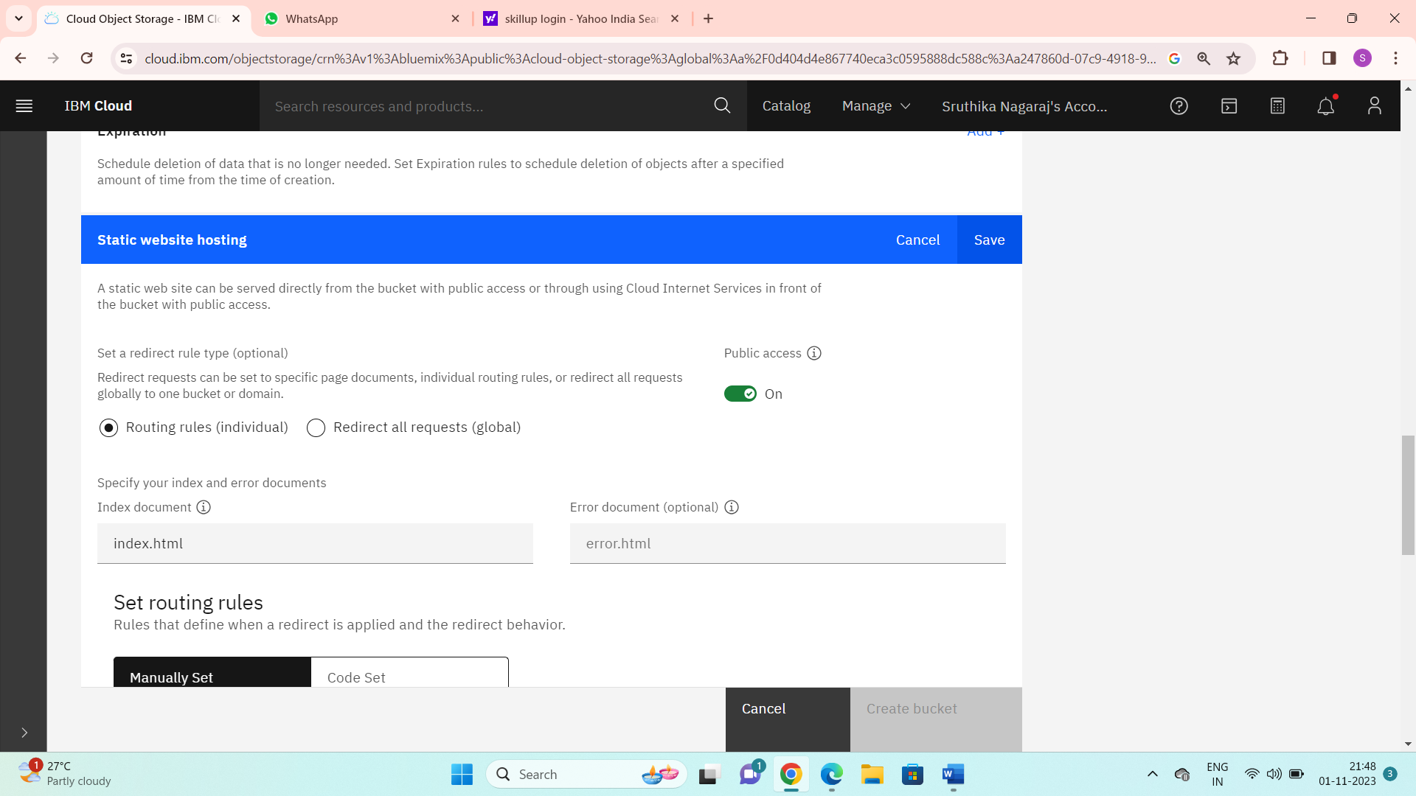

Click on create bucket. Now the bucket is created.

Step 8: Upload the files and folders to the bucket.

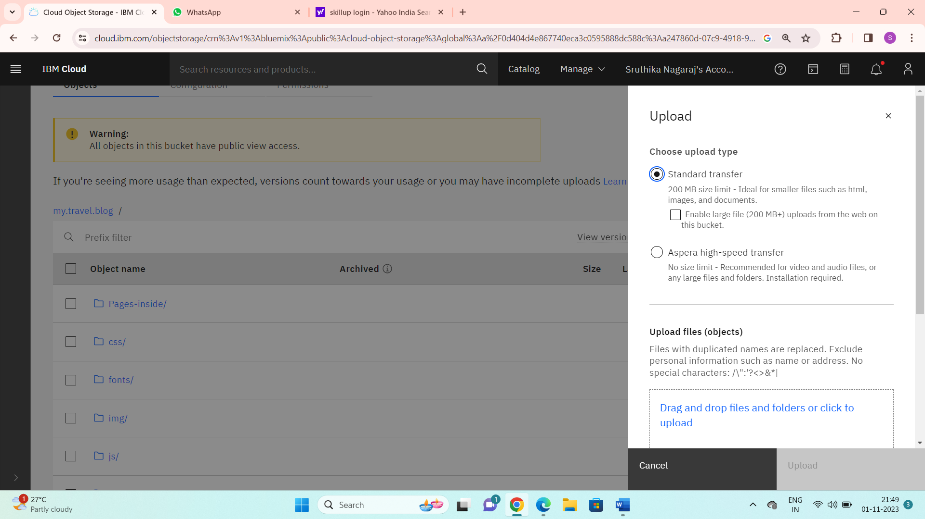

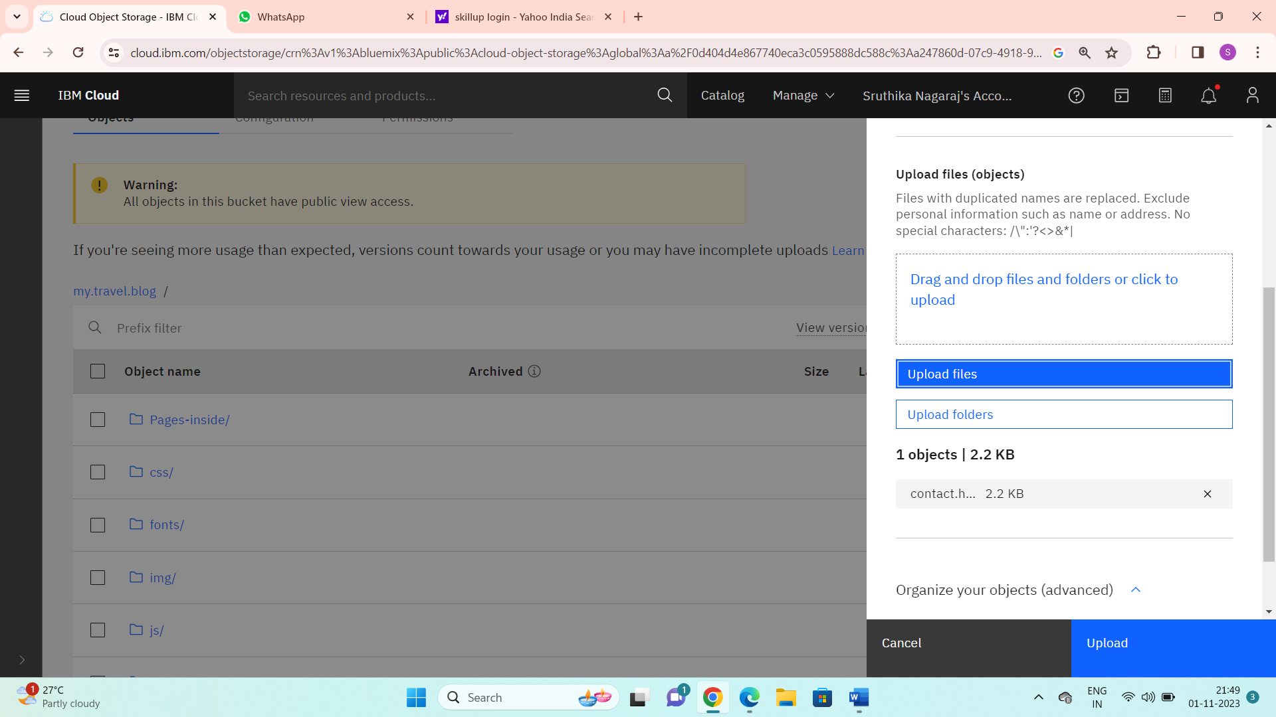

Step 9: You can view the configuration page.

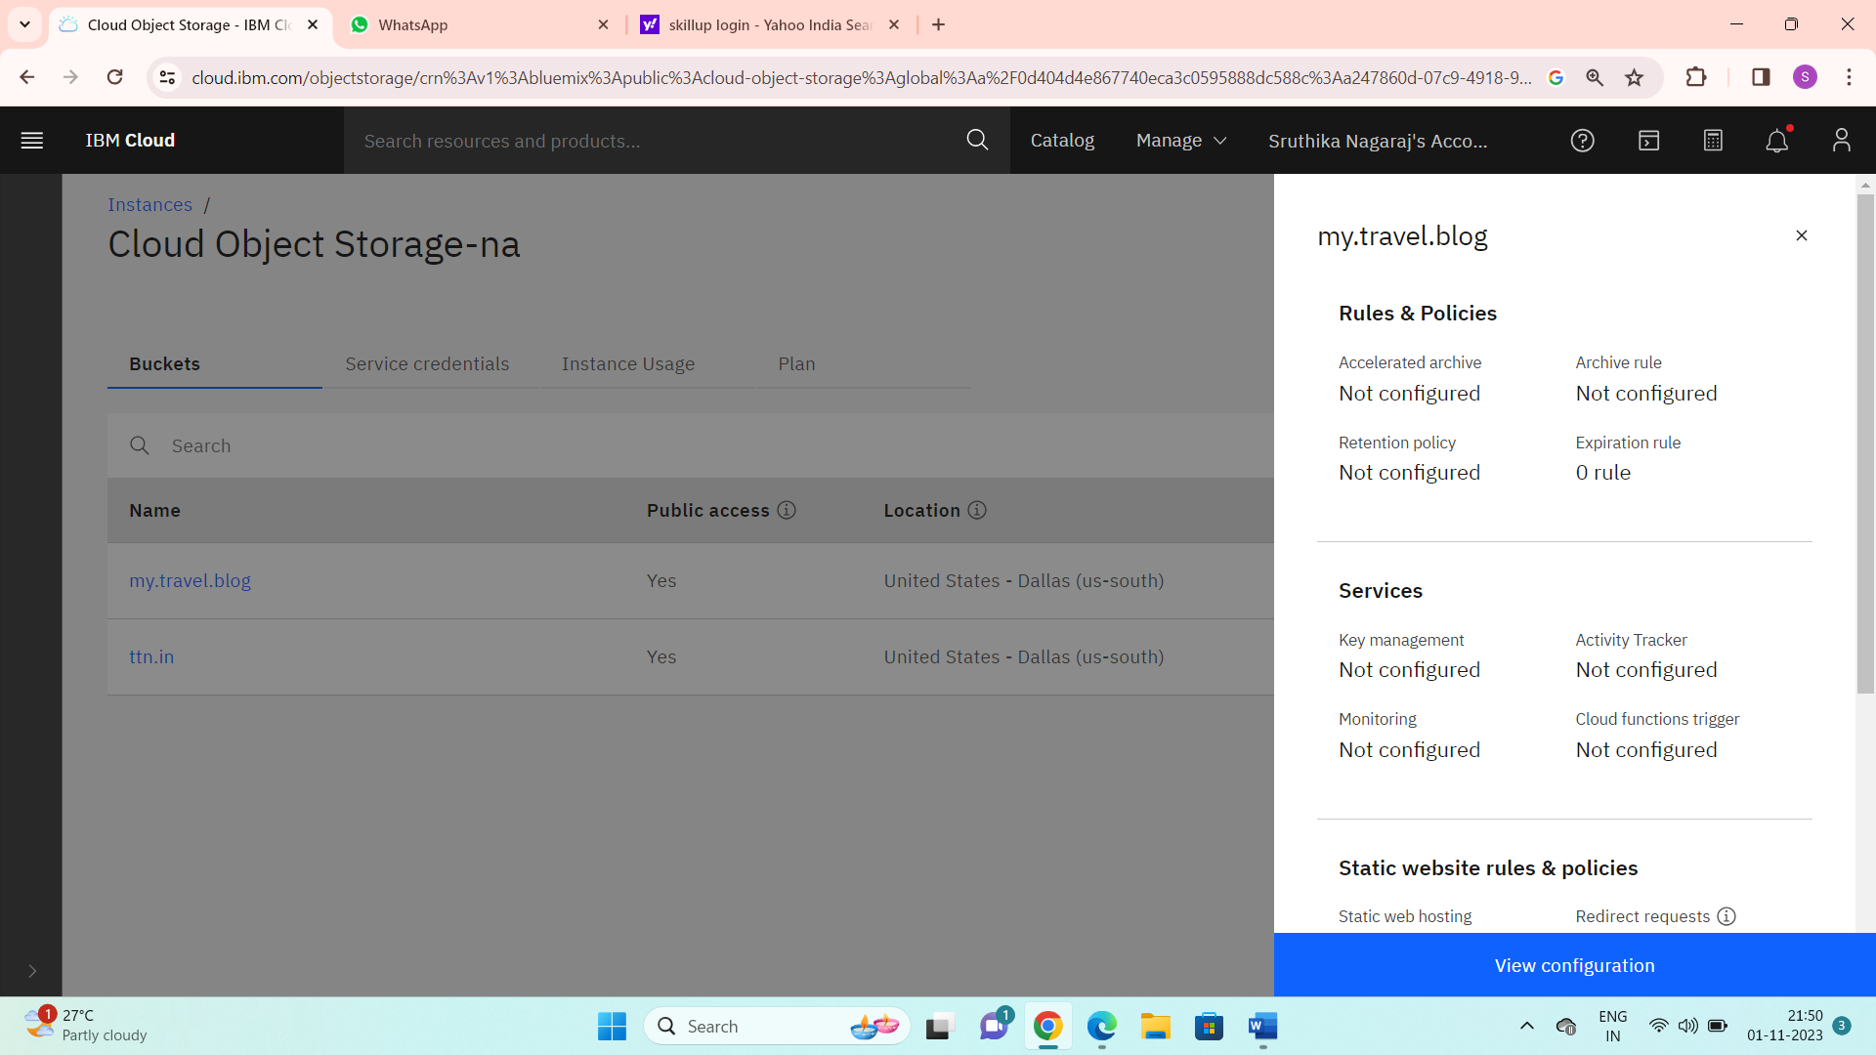

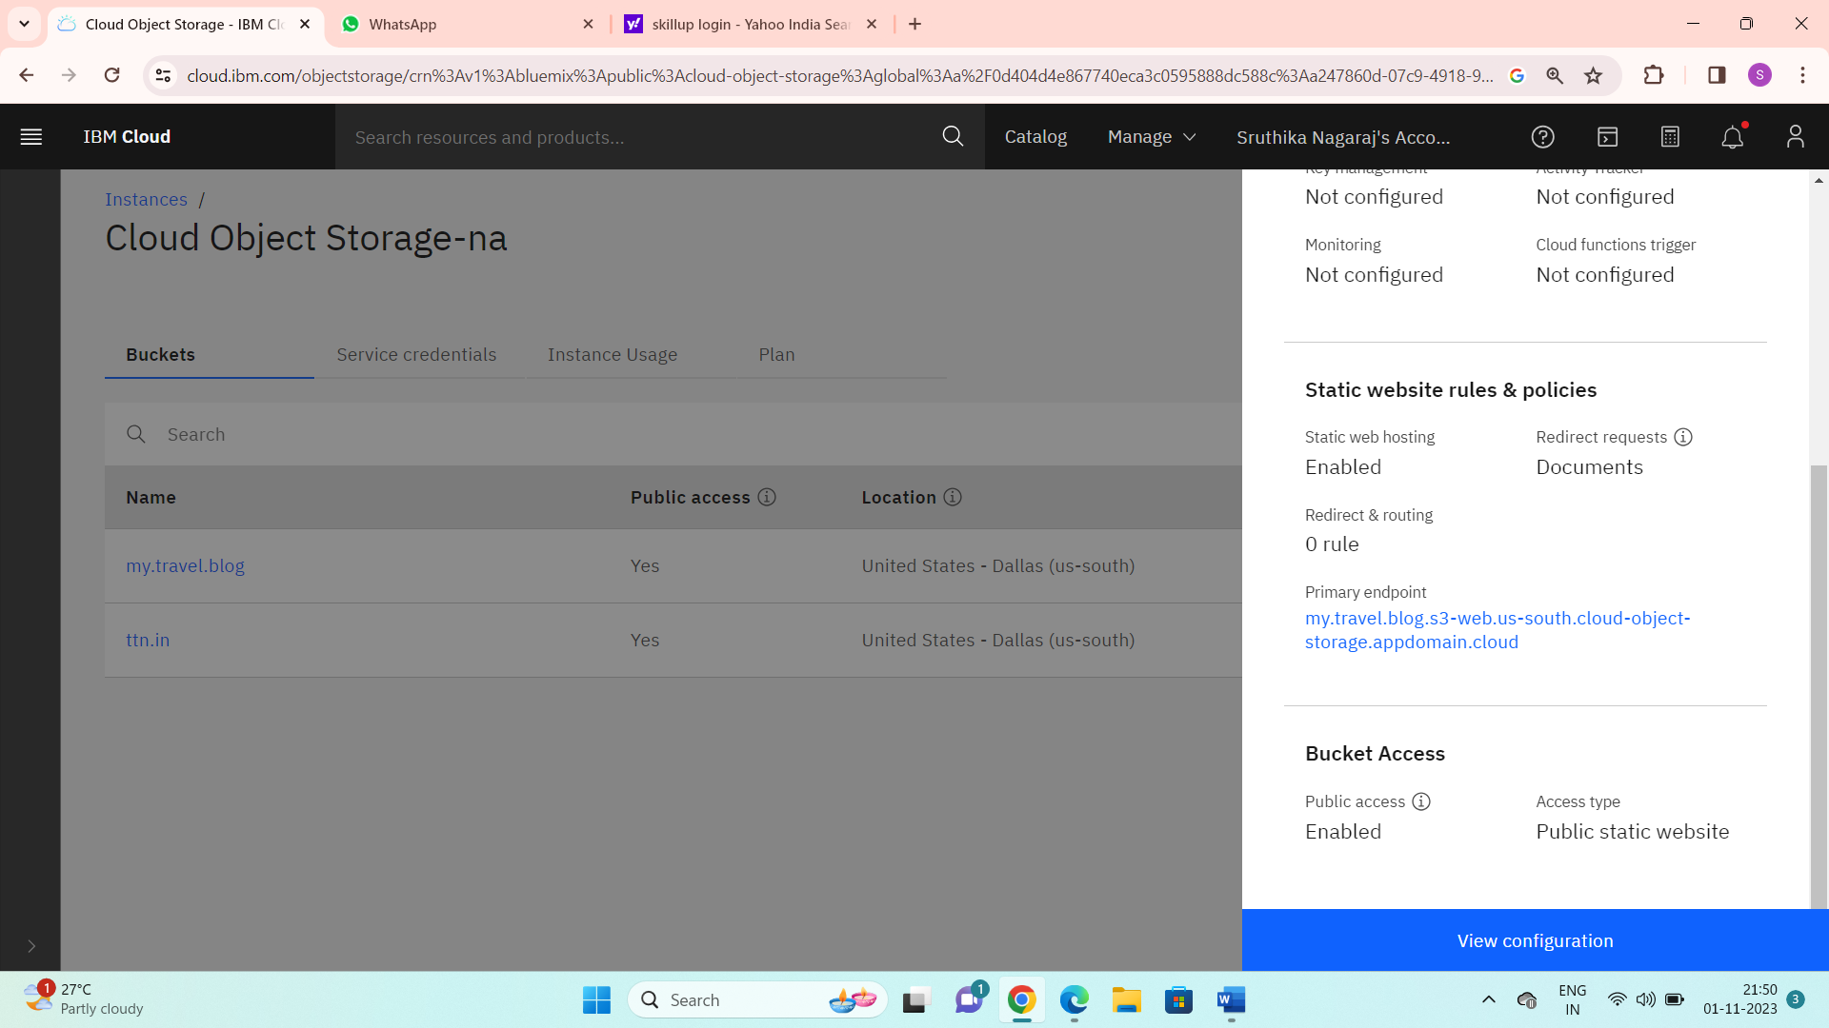

Step 10:

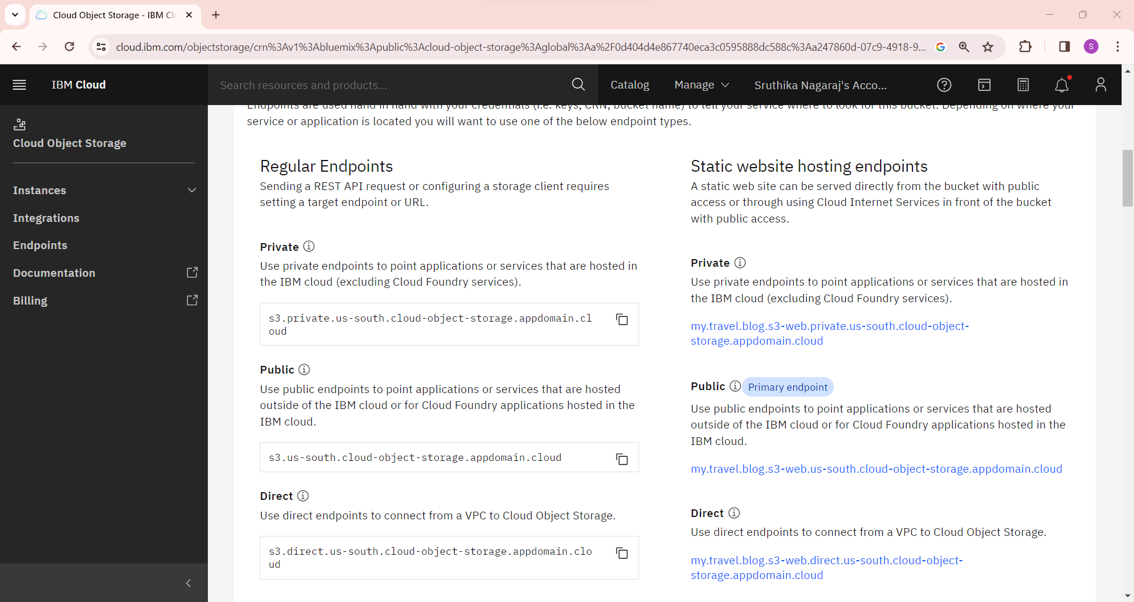

## PERSONAL BLOG USING IBM CLOUD STATIC WEB APPS

## Website link:

<https://my.travel.blog.s3-web.us-south.cloud-object-storage.appdomain.cloud/>

**PLATFORM LAYOUT:**

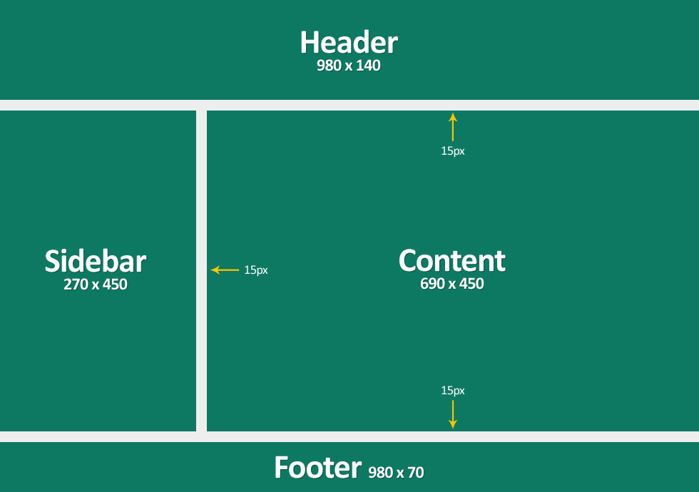

**PLATFORM FEATURES:**

**About**

Tour Tamil Nadu is your ultimate guide to exploring the rich and diverse landscapes of this beautiful Indian state. We are dedicated to providing you with comprehensive information about the aesthetic and fascinating places that Tamil Nadu has to offer. Whether you're interested in the ancient temples, stunning beaches, lush hill stations we've got covered.

Our goal is to make your travel experience as smooth as possible. If you have any questions or need assistance, you can post your queries, and our knowledgeable team will be there to help.

**Service:**

In addition to the wealth of information, we also offer our contact information to ensure that you can reach out to us easily. Whether you need recommendations, travel tips, or personalized advice, our team is just a message or call away. So, if you're planning a trip to Tamil Nadu or simply want to learn more about this enchanting state, Tour Tamil Nadu is your go-to resource for all things Tamil Nadu travel-related. Explore, discover, and experience the beauty of Tamil Nadu with us.

**TECHNICAL IMPLEMENTATION:**

The technical implementation involves using a combination of HTML, CSS, JavaScript, and Bootstrap, all within the development environment of Visual Studio Code. This setup is for efficiency and versatility.

HTML is the foundation of web content, providing the structure and markup for our web pages. CSS enhances the visual presentation of these pages, allows to define styles, layouts, and aesthetics. JavaScript, a powerful scripting language, enables dynamic and interactive functionality on website.

Bootstrap is a front-end framework that simplifies the process of creating responsive and attractive web designs. It offers a set of pre-designed components and responsive grid systems, making it easier to build web application that look good on various devices.

Visual Studio Code is a lightweight and feature-rich code editor that’s highly customizable and offers a variety of extensions to support web development. It provides a smooth workflow for writing, debugging, and testing code.

By using this technology stack and development environment, create web applications that are both visually appealing and functionally robust.

**SCREENSHOTS OF OUR PERSONAL TRAVEL BLOG WEB APPS**

**WEBSITE:**

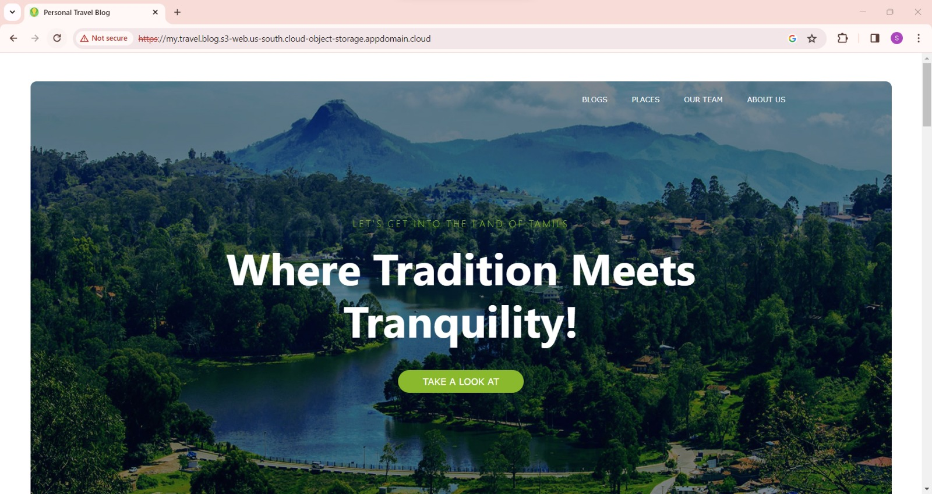

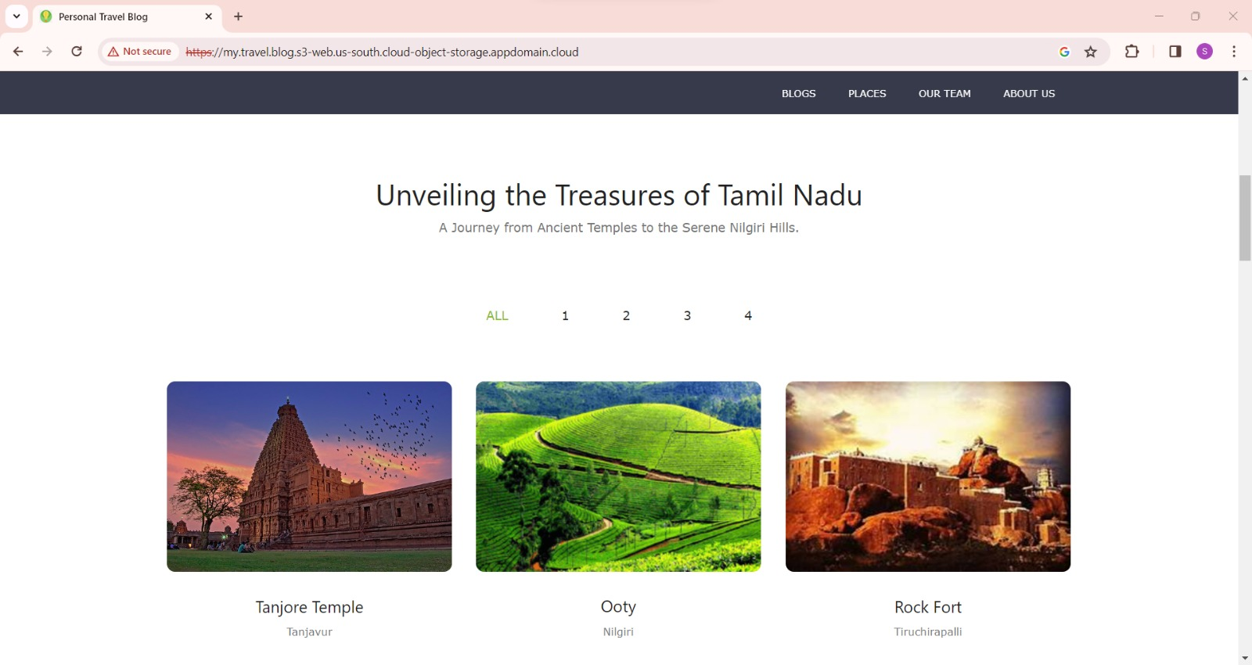

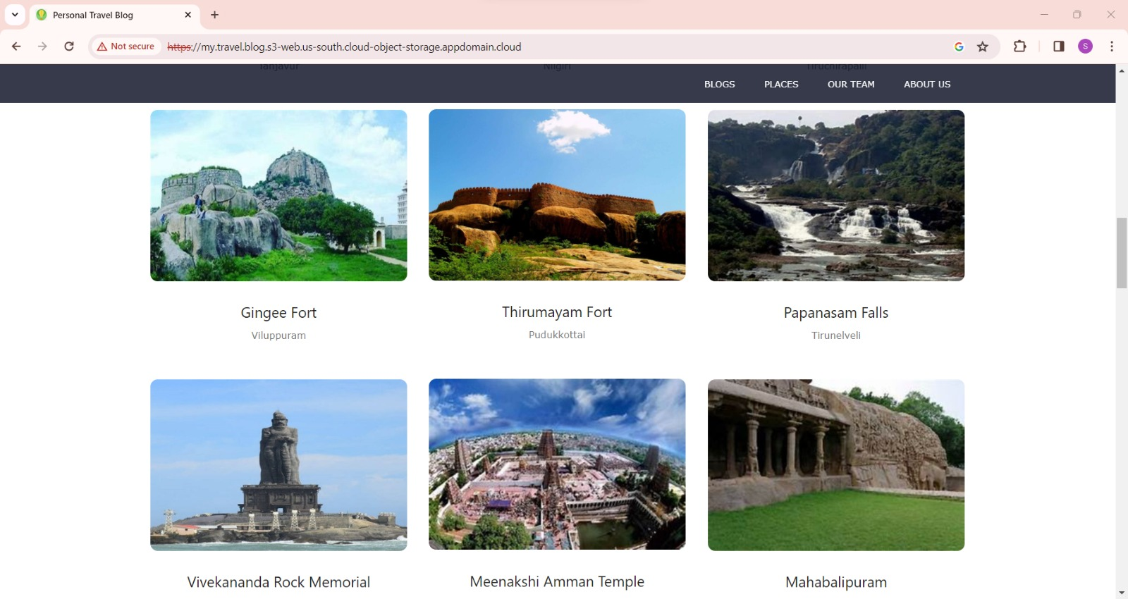

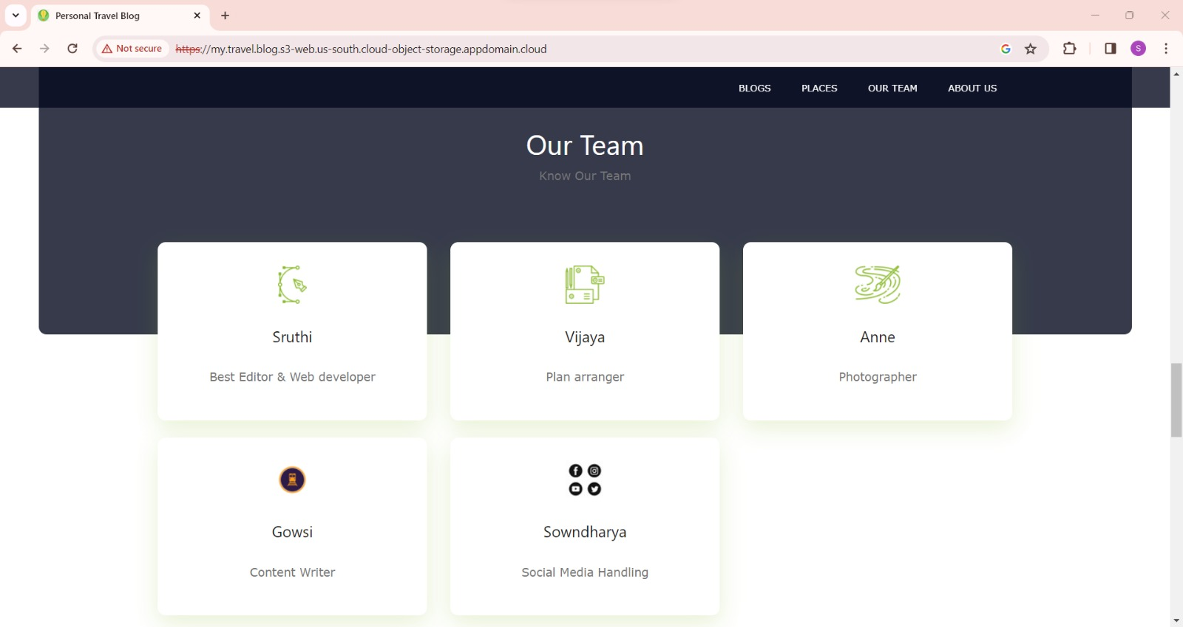

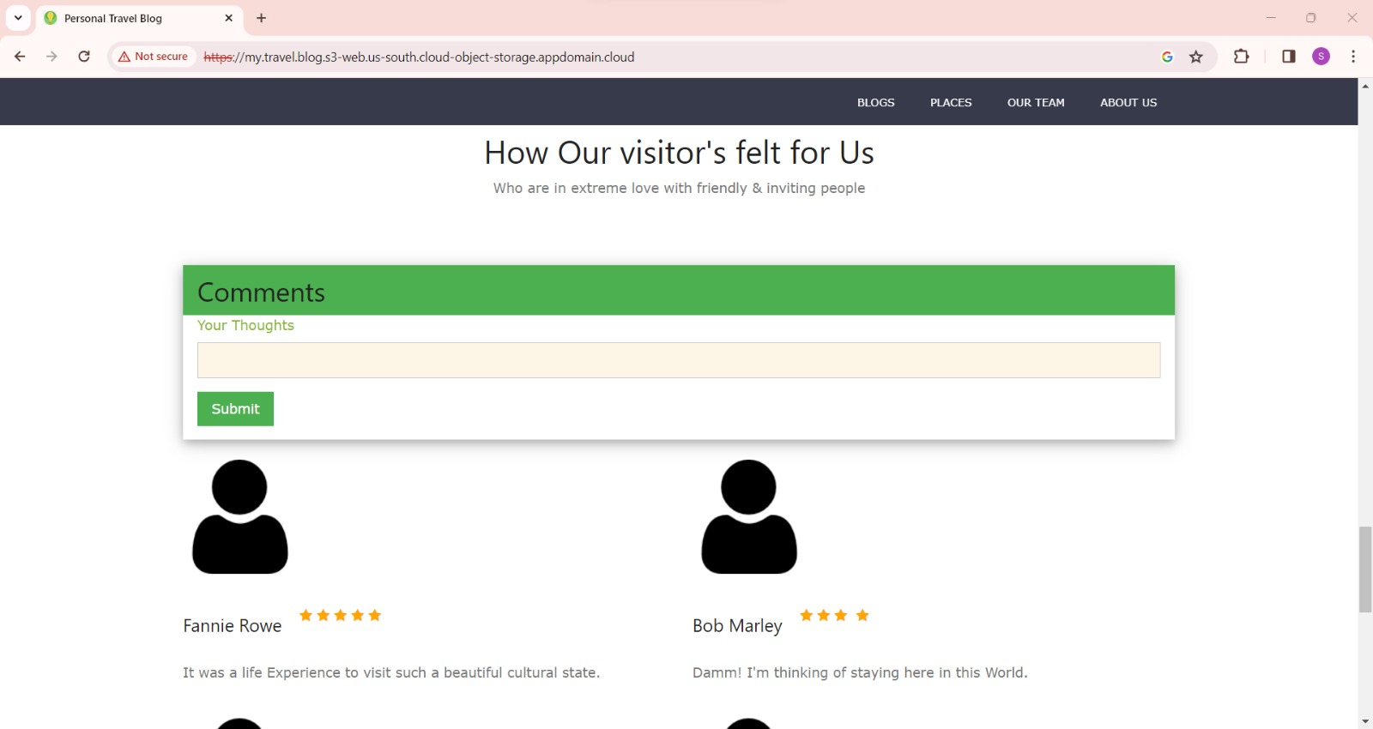

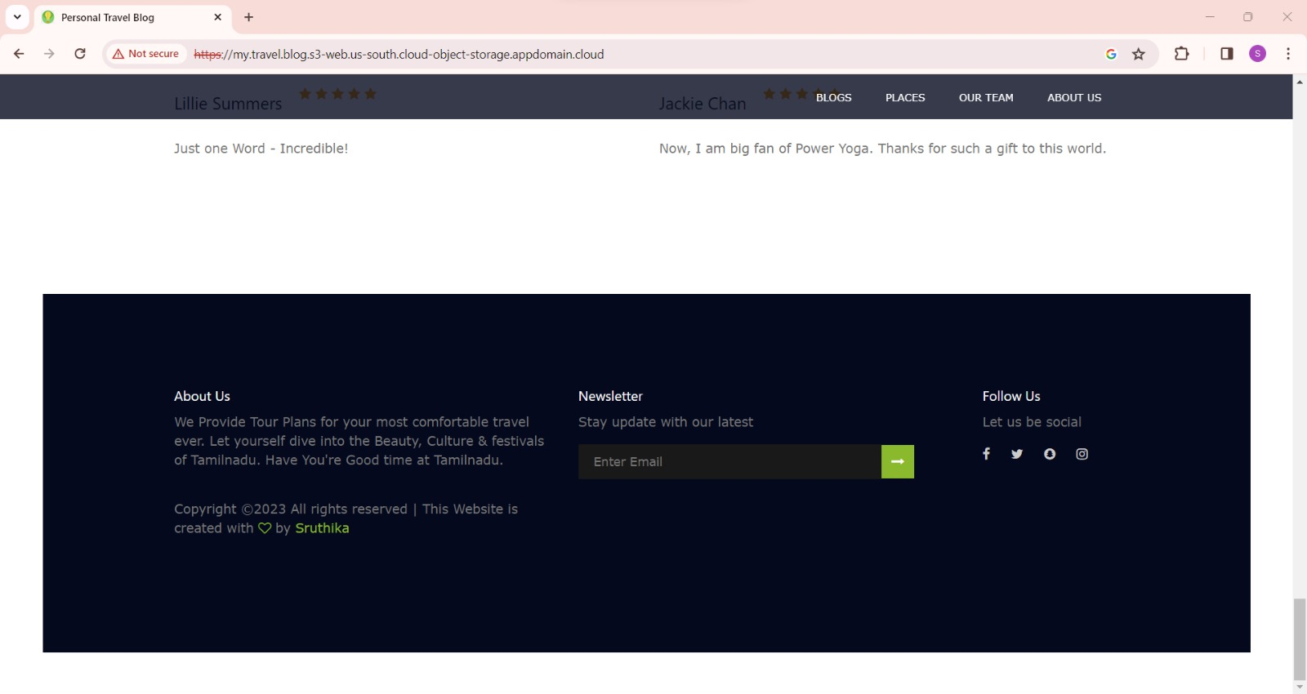

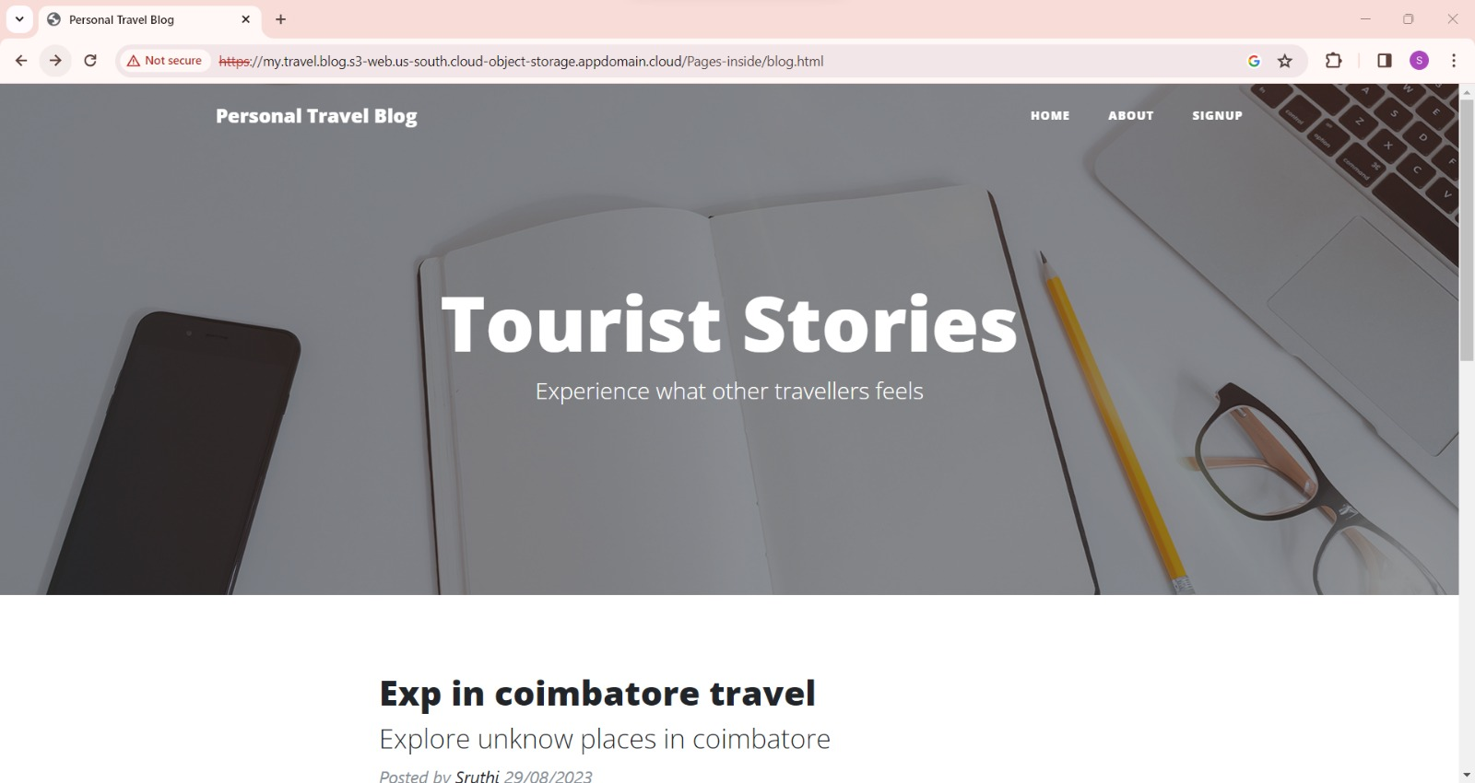

**ABOUT:**

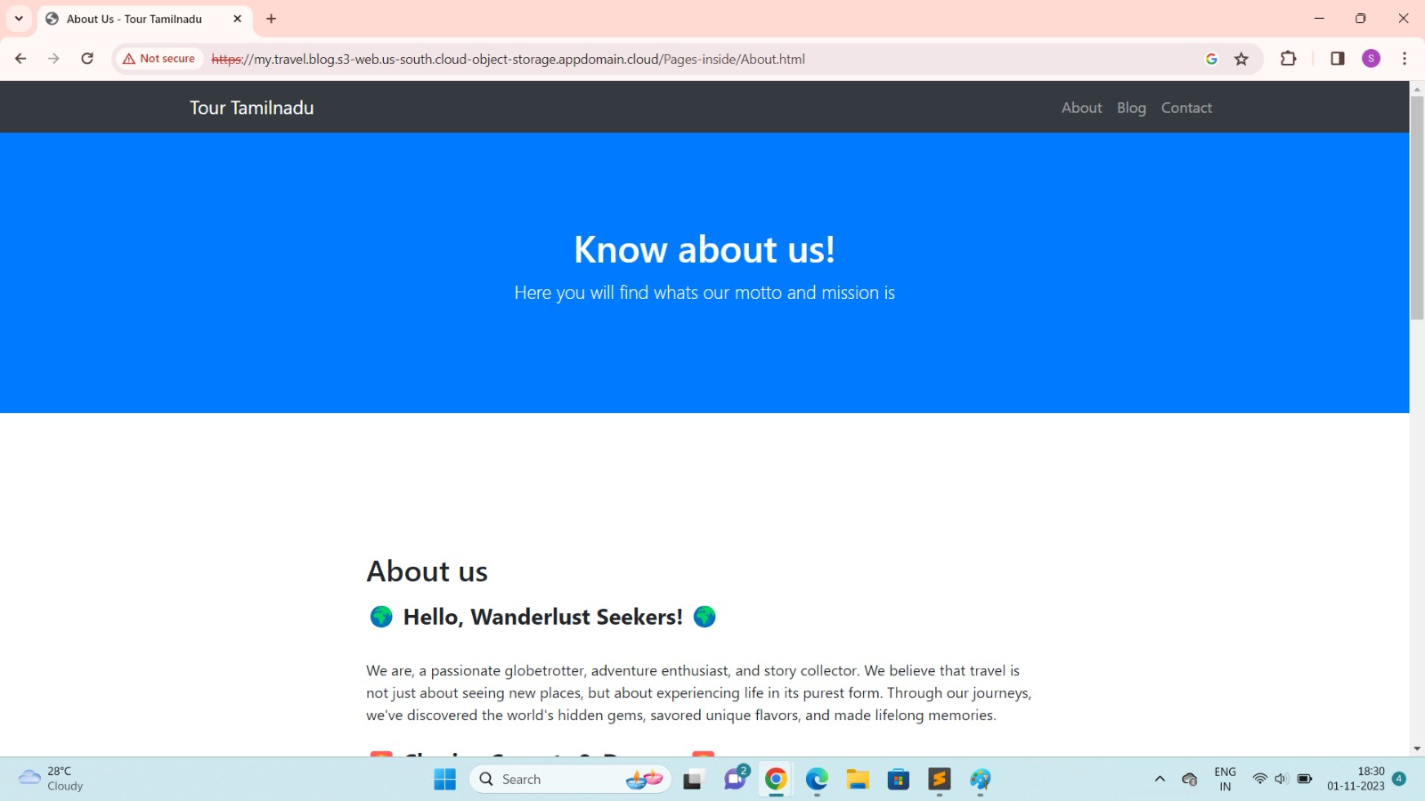

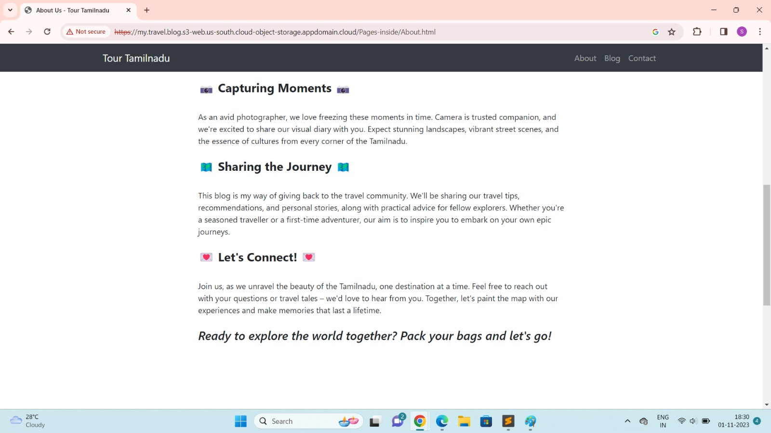

**CONTACT:**

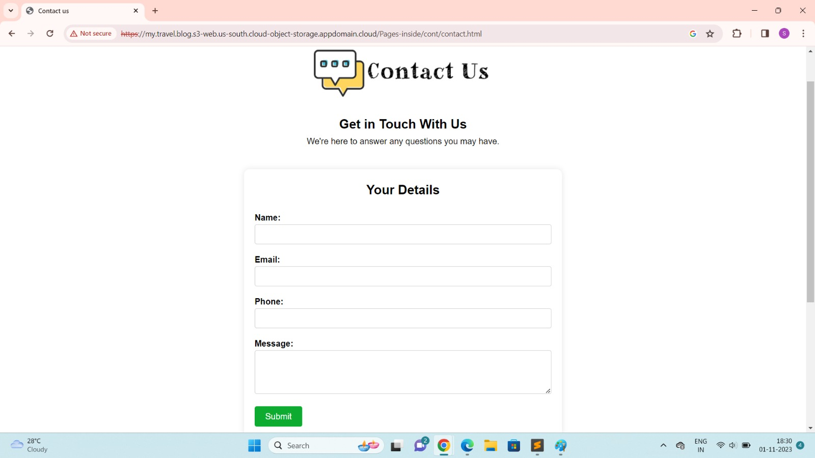

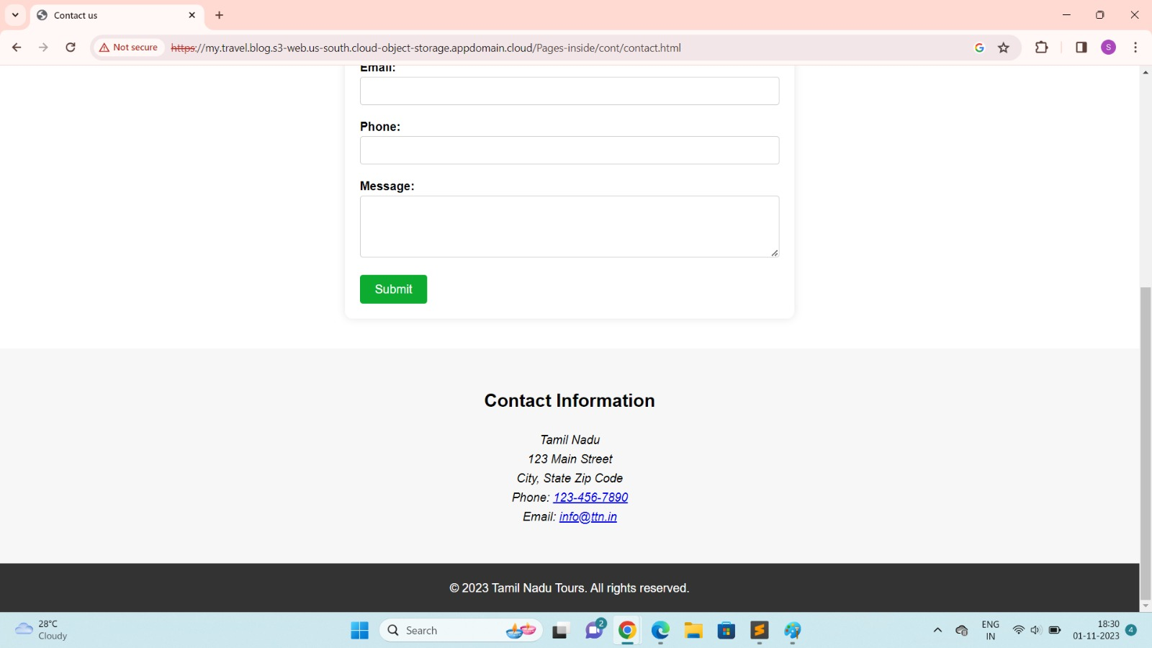

**BLOG:**

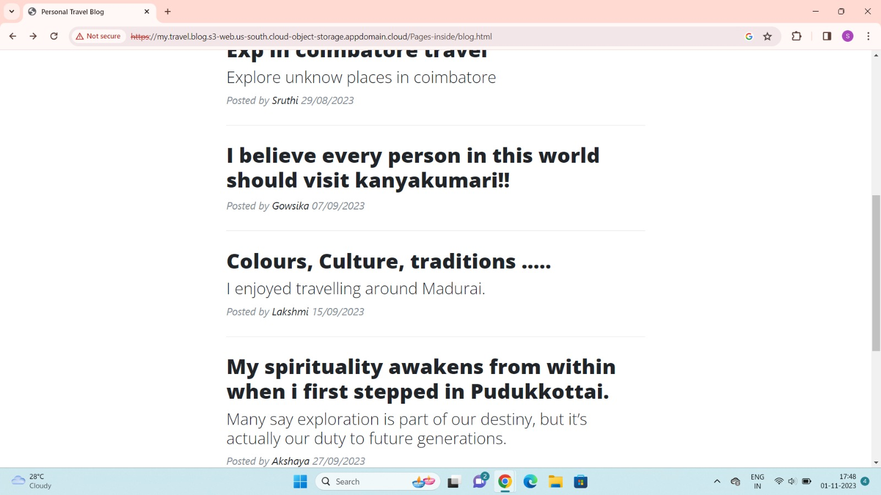

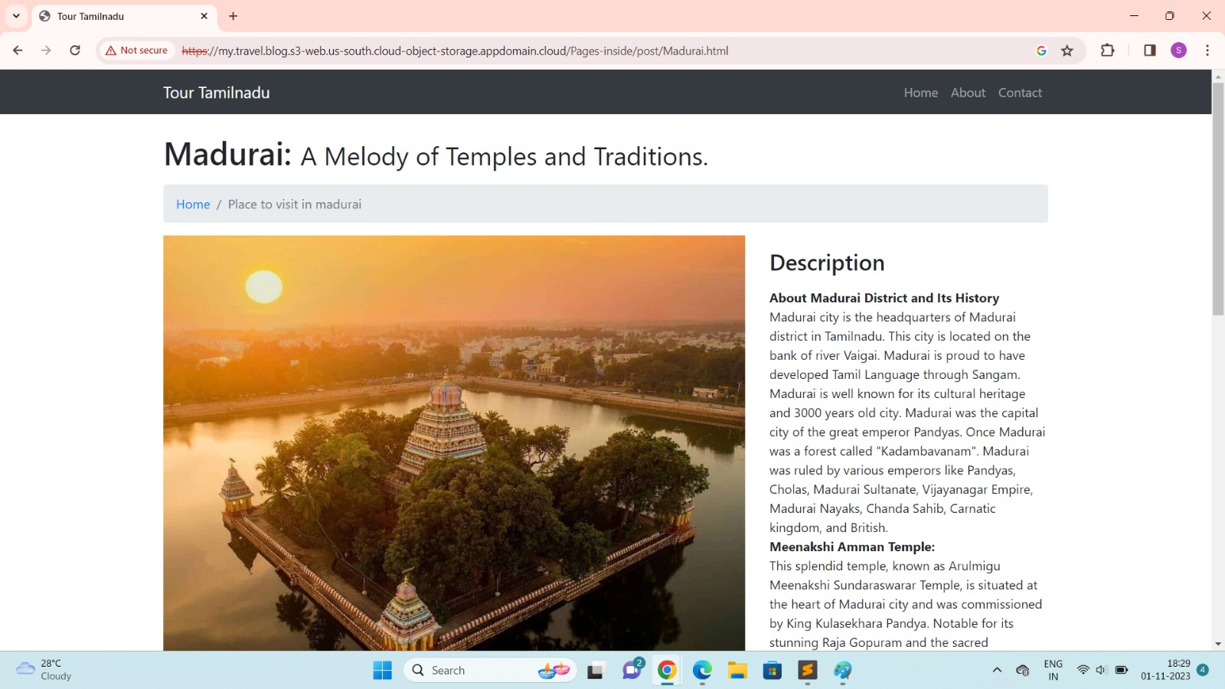

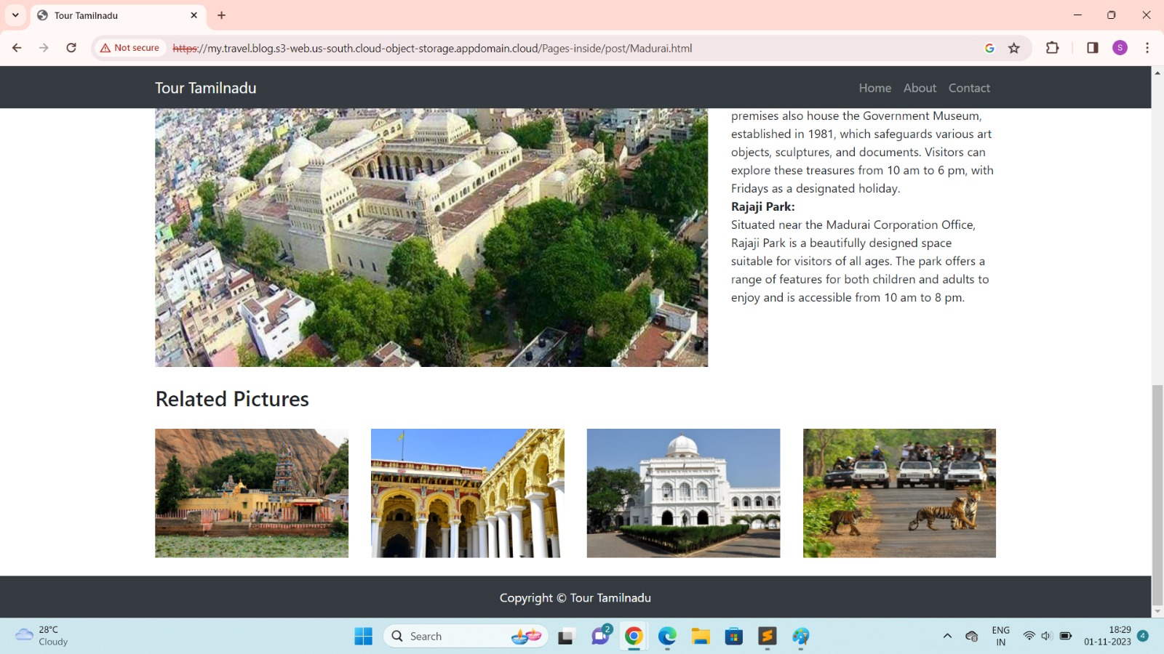

## CONCLUSION:

personal travel blog hosted on IBM Cloud Static Web Apps. Sharing our travel adventures, tips, and captivating photos with the world. Use IBM Cloud Static Web Apps to easily update your blog and document our journeys. Inspire others to explore the beauty of the world and forge unforgettable memories! IBM Static Web Apps has proven to be a reliable and user-friendly platform, allowing us to focus on what I love. Without worrying about the technical complexities of web hosting.